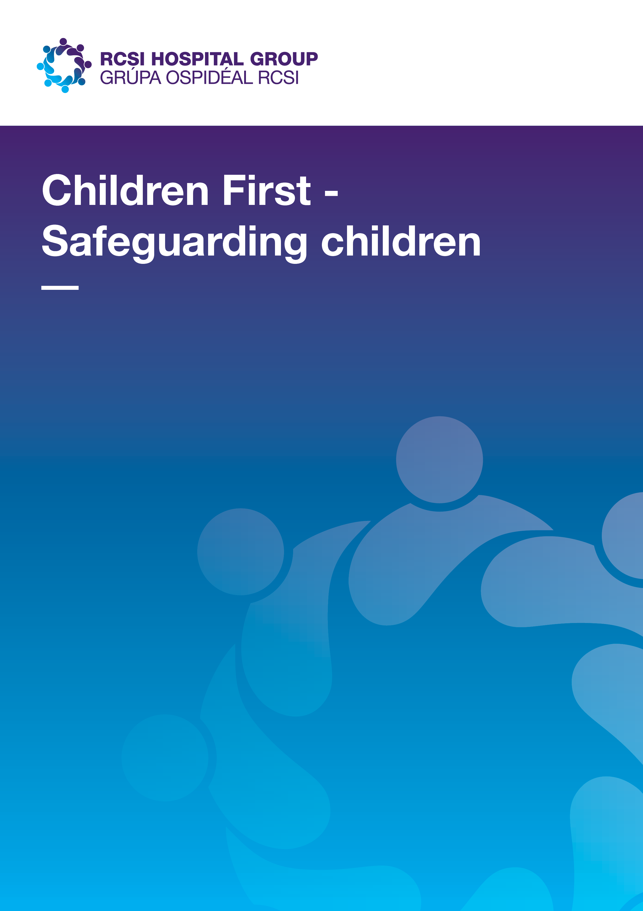

**Children First - Safeguarding children**

Quality and safe patient care is a priority for RCSI the Hospital Group, committed to developing a strong safeguarding culture, across all services. This is especially important for the safeguarding and protection of children. The RCSI Hospital Group, across all hospital sites aims to ensure full compliance with national legislation.

*“It is everyone’s responsibility to protect children and young people and to do our best to keep them safe. It is important that families, communities and professionals can recognise when a child or young person is being harmed and that they know what action to take in response.”* Children First National Guidance for the Protection and Welfare of Children 2017 <https://www.tusla.ie/uploads/content/Children_First_National_Guidance_2017.pdf>

**Tusla Child & Family Agency**

Tusla and Family Agency was established on January 1, 2014, and is the dedicated Irish state agency responsible for improving wellbeing and outcomes for children in Ireland. They are an independent legal entity dedicated to child protection reform, early intervention and family support services, across Ireland. “*This agency was established under the Child and Family Act 2013 and is charged with supporting and promoting the development, welfare and protection of children and effective functioning of families.”* The[**Children First Act 2015**](http://www.oireachtas.ie/documents/bills28/acts/2015/a3615.pdf) was enacted November 19, 2015 and commenced in full on December 11, 2017. This Act places statutory obligations on specific groups of professionals and organisation providing services to children. This act intends to:

* *Raise awareness of child abuse and neglect*
* *Provide for mandatory reporting by key professionals*
* *Improve child safeguarding arrangements in organisations providing services to children*
* *Provide for cooperation and information-sharing between agencies when Tusla – Child and Family Agency, is undertaking child protection*

It also operates alongside the existing non statutory obligations under Children First: National Guidance for the Protection and Welfare of Children (2017).

**Resources:**

1. Tusla website <https://www.tusla.ie/about/>
2. <https://www.tusla.ie/uploads/content/Children_First_National_Guidance_2017.pdf>

**Children First National Guidance for the Protection & Welfare of Children** was launched on October 2, 2017. It outlines the procedural steps to be taken by all in society to ensure that the child or young person is protected from harm. It is updated to also include new information about the Children First Act 2015 with specific reference to the legislative obligations of professionals and organisations to keep children safe.

**Hospital Responsibilities:**

1. **Children First National Guidance for the Protection & Welfare of Children** outlines the requirement for all services working with children and young people to create and promote a culture of safety for those availing of their services. All hospitals are ‘relevant services’ as defined in the Children First Act 2015 thus having statutory obligations to ensure children and young people are protected from harm in their organisation as well as outlining best practice for dealing with children and young people.

**Statutory obligations of all services are:**

* Keep children **safe from harm** while they are using the service
* Carry out a **risk assessment** to identify whether a child or young person could be harmed while availing of the service
* Develop a **Child Safeguarding Statement** that outlines the policies and procedures which are in place to manage the risks that have been identified
* Appoint a **relevant person** to be the first point of contact in respect of the organisation’s Child Safeguarding Statement

[**https://www.tusla.ie/children-first/organisations/**](https://www.tusla.ie/children-first/organisations/)

[***https://www.tusla.ie/uploads/content/Children_First_National_Guidance_2017.pdf***](https://www.tusla.ie/uploads/content/Children_First_National_Guidance_2017.pdf)

**Mandated Persons**

The Children First Act 2015 places a legal obligation on certain professionals who must report child protection concerns to Tusla Child & Family Agency. On request, Mandated Persons must also assist Tusla in the assessment of children or young people who are the subject of a mandated report.

Mandated Persons are people and professionals who have contact with children and/or families and are in a position to help protect children from harm. They are key professionals working with children in the education, health, justice, youth and childcare sectors as well as those with indirect contact with children such as adult counselling, psychiatry, members of the clergy or pastoral care workers.

The Children First Act 2015, Schedule 2, provides a full list of people classified as Mandated Persons.

[**https://www.tusla.ie/uploads/content/230920_TUSLA_-Information_for_Mandated_Persons.pdf**](https://www.tusla.ie/uploads/content/230920_TUSLA_-Information_for_Mandated_Persons.pdf)

**Further Resources:**

For all questions and guidance queries relating to Children First, please visit the Tusla website

[**https://www.tusla.ie/children-first/publications-and-forms/**](https://www.tusla.ie/children-first/publications-and-forms/)